Little Acorns Menu Week 2
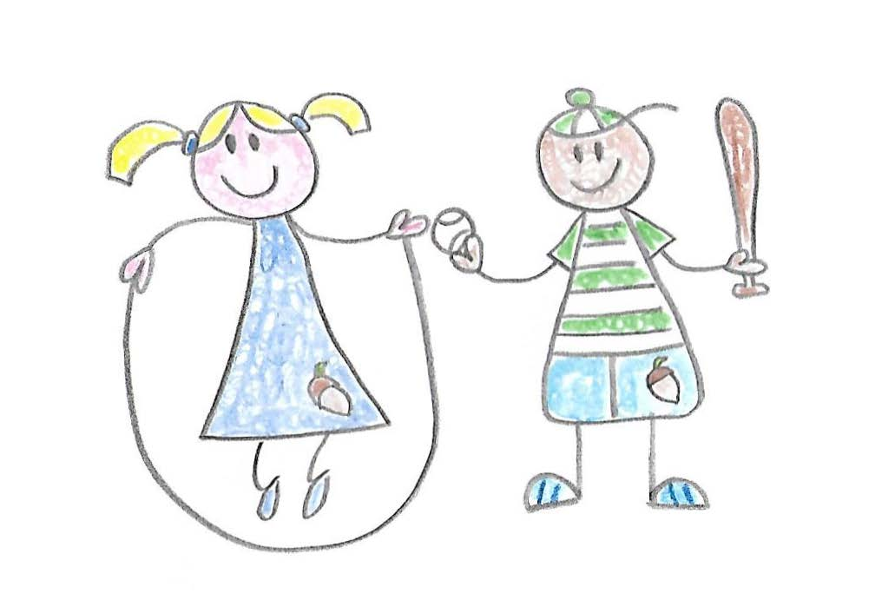
Monday | Tuesday | Wednesday | Thursday | Friday
Wholegrain cereal  Fruit | Wholegrain cereal  Fruit | Wholegrain cereal  Fruit | Wholegrain cereal  Fruit | Wholegrain cereal  Fruit
Oatcake | Breadsticks/ crackers | Wholemeal crackers | Breadsticks/ crackers | Breadsticks/ crackers
Sausage and bean casserole with mash and vegetables (2 portions of veg per bowl) | Pea, lentil and potato curry (2 portions of veg per bowl) | Chicken with greens, carrots and potatoes | Salmon and wholegrain pasta in a cream cheese, tomato and vegetable sauce with garlic bread | Shepherds pie (with peas and sweetcorn)
Fruit break | Fruit break | Fruit break | Fruit break | Fruit break
Afternoon Tea  Tuna sandwich, cucumber, celery sticks and yoghurt dip | Afternoon Tea  Chicken pitta with carrot sticks and yoghurt dip | Afternoon Tea  Homemade hummus, pasta twists, carrot sticks, chopped peppers and yoghurt dip | Afternoon Tea  Lentil and root vegetable soup (with 2 portions of veg per bowl) | Afternoon Tea  Ham sandwiches with chopped apple, carrot sticks and yoghurt dip

